HELLO CHILDREN
Today is Wednesday.
( Wednesday – środa)
How are you?
Dziś poznamy piosenkę o słoneczku
„Mr Golden Sun”
Najpierw nauczymy się słówek :
sun – słońce ( san)

shine –świecić (szajn)

hide – chować się ( chajd) 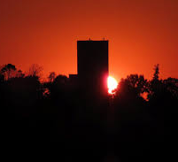

tree – drzewo 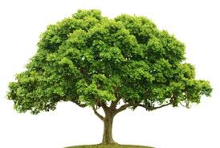(czri)

Czas na piosenkę : https://youtu.be/hlzvrEfyL2Y
Poniżej znajdziecie słowa piosenki:

Oh Mr. Sun, Sun, Mr. Golden Sun,
please shine down on me.
Oh Mr. Sun, Sun, Mr. Golden Sun,
hiding behind the tree.
These little children are asking you
to please come out so we can play with you.
Oh Mr. Sun, Sun, Mr. Golden Sun.
Please shine down on me.
Shine down on me. Shine shine shine.
Shine down on me. Shine shine shine.
Shine down on me. Shine shine shine.
Shine down on me.
Mr. Sun, Mr. Sun, Mr. Golden Sun.
Oh Mr. Sun, Sun, Mr. Golden Sun,
please shine down on me.
Oh Mr. Sun, Sun, Mr. Golden Sun,
hiding behind the tree.
These little children are asking you
to please come out so we can play with you.
Oh Mr. Sun, Sun, Mr. Golden Sun.
Please shine down on,
please shine down on,
please shine down on me.

EXERCISE NUMBER 1
Cut and colour the sun. Wytnij i pokoloruj słoneczko.
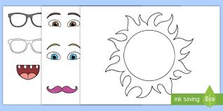
HAVE A GOOD DAY MIŁEGO DNIA!!!!!

